

Name: Abdelatef Osama Abdelatef Torky
DR/Mohamed Abdelhamed
Report 1 => RIPV2

Objective
To Achieve Routing Protcol Ripv2
Tools
Ensp & Cisco Packet Tracker
Subject
This project demonstrates the implementation of dynamic routing using RIP version 2 to enable communication between different networks. The network is designed using IPv4 addressing without using NAT, as the devices are configured to communicate directly through routing tables.
The IP address 40.0.0.1 is reachable through RIPv2 routing updates, where routers exchange routing information automatically to learn the best path to the destination network. After configuring RIPv2 and advertising the connected networks, packets are forwarded based on the routing table entries rather than static manual routes.
In this design, NAT was not applied since the network operates within private/internal addressing and does not require address translation.
Cisco Packet Tracker
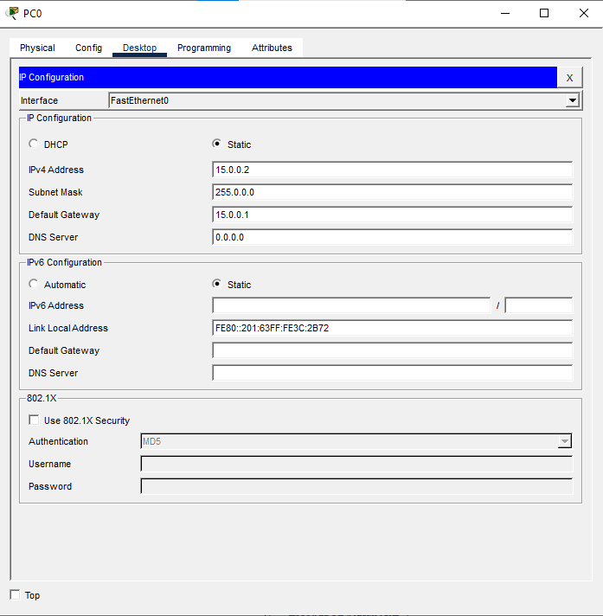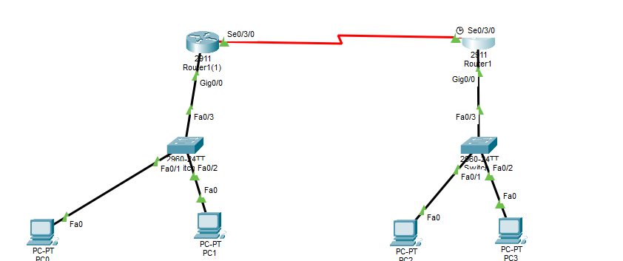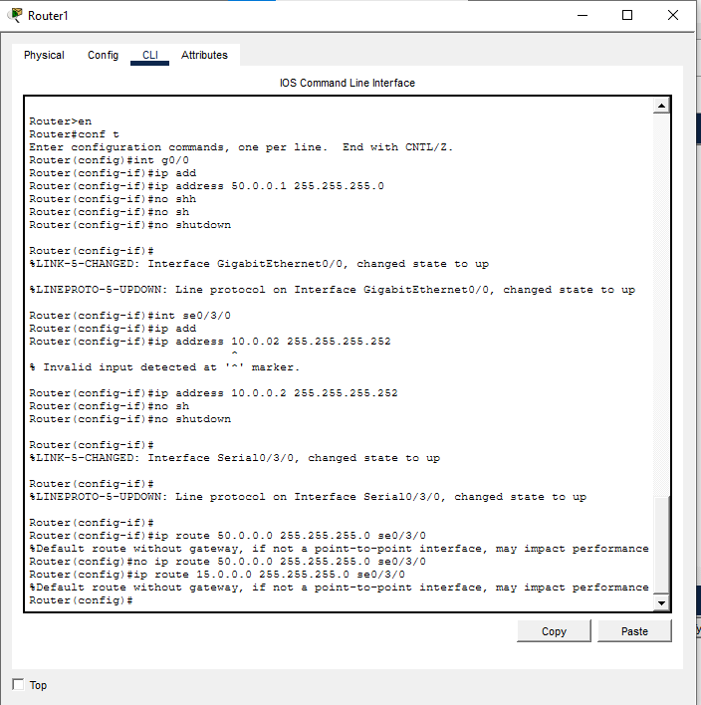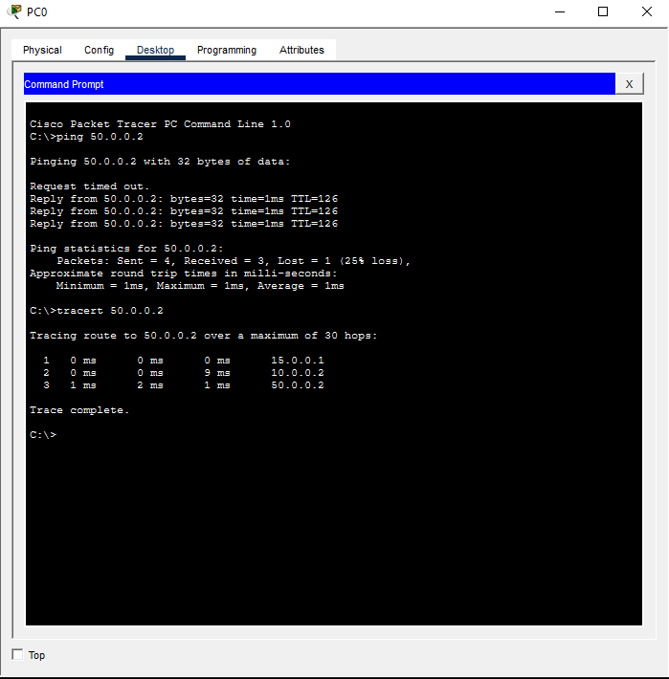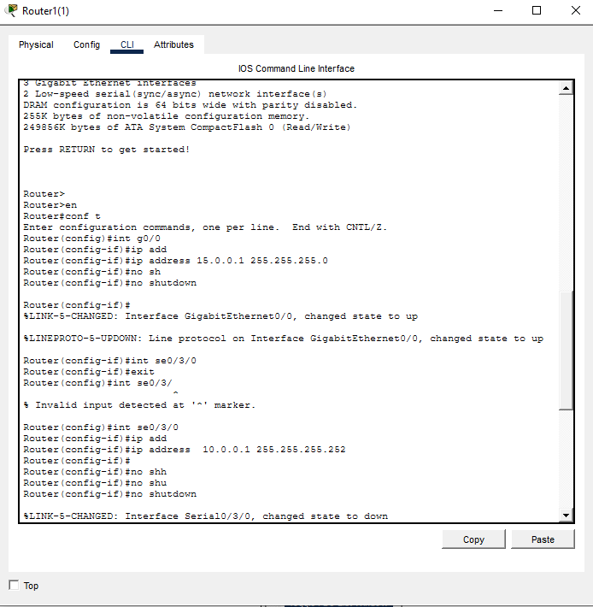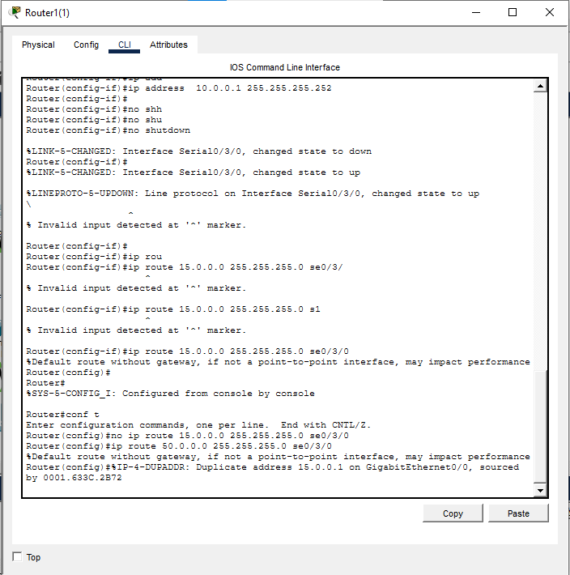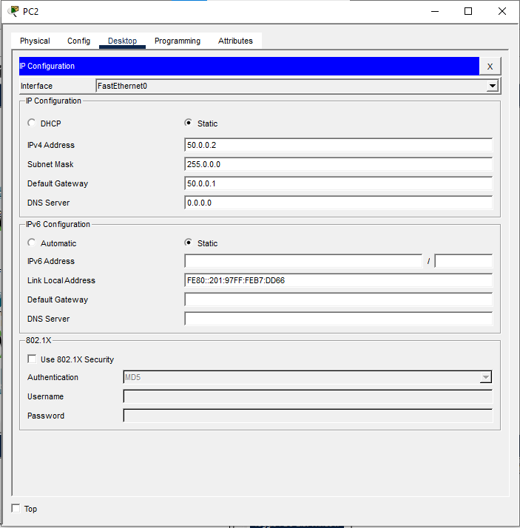

eNSP
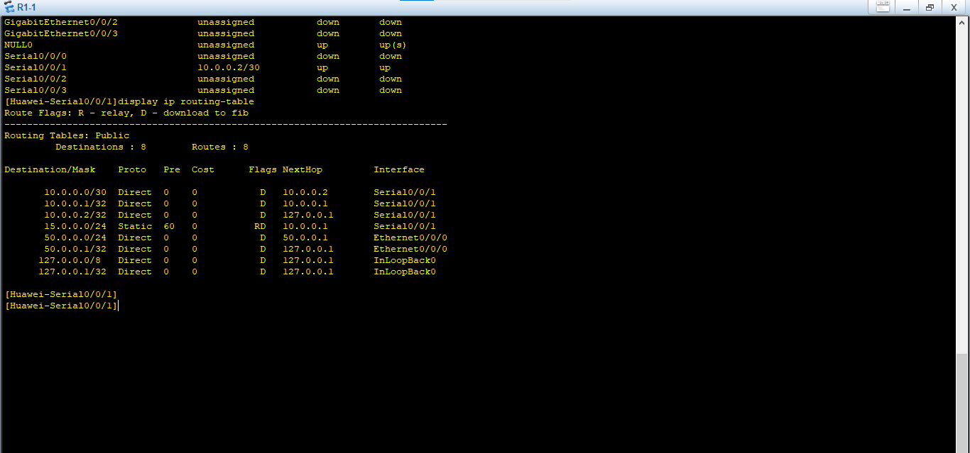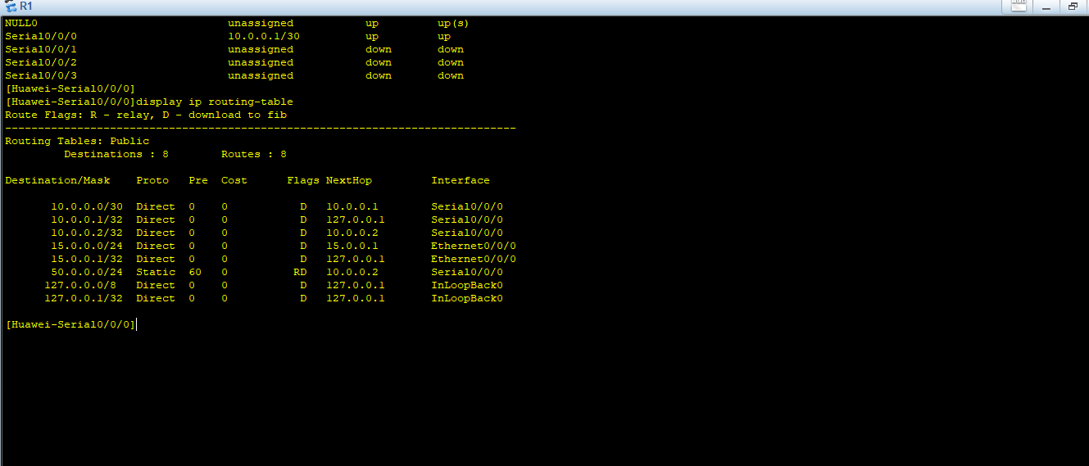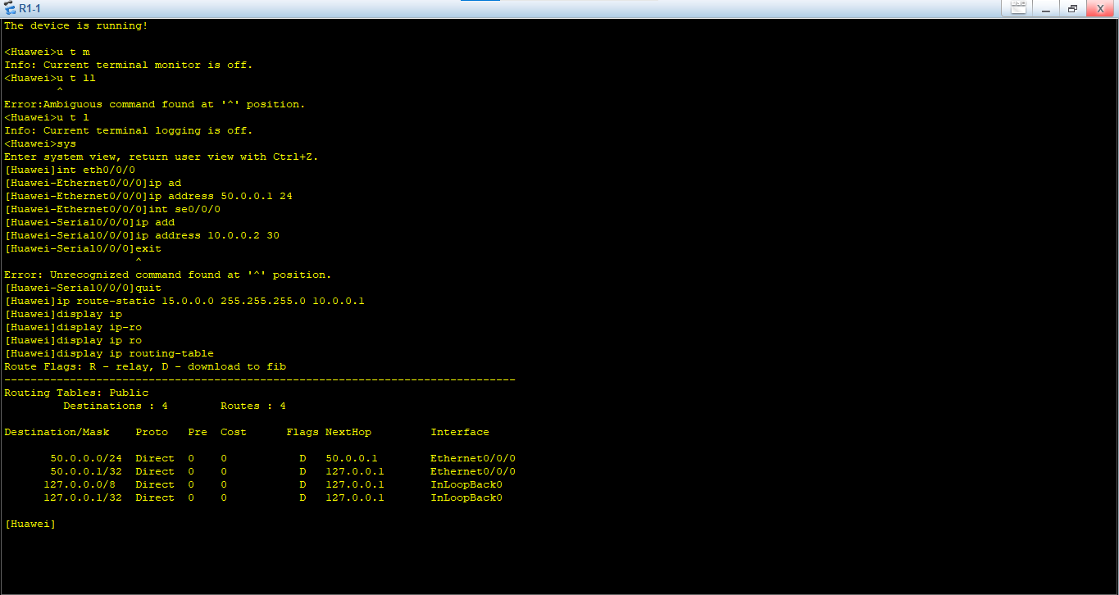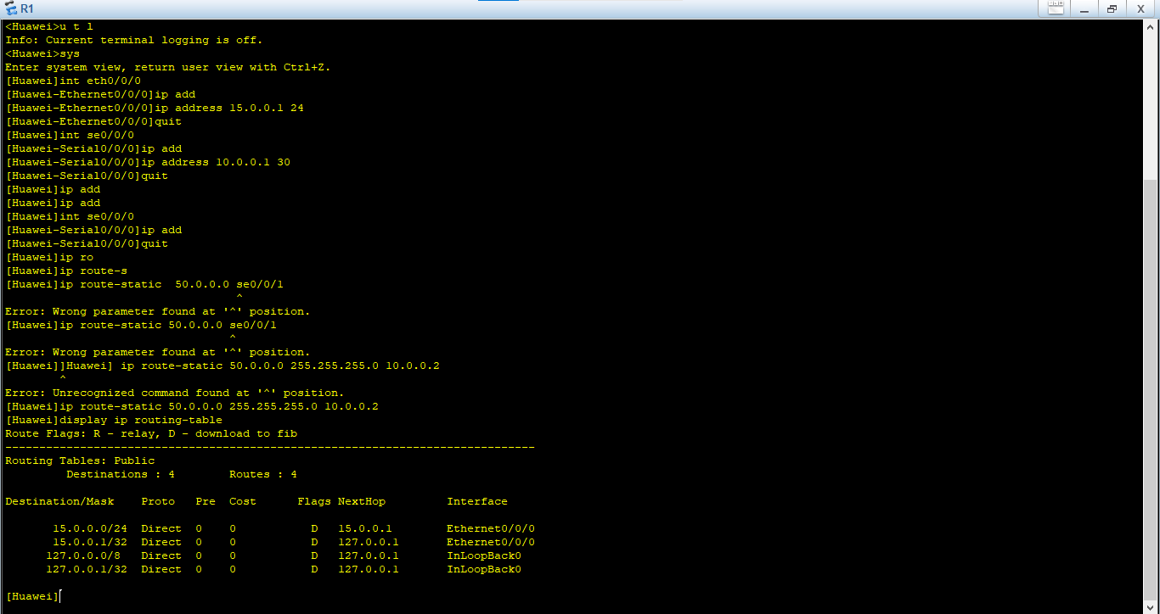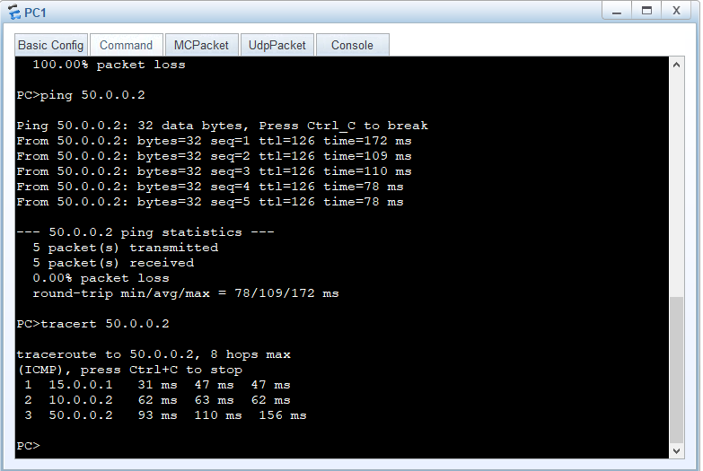

Conclusion
In conclusion, RIP version 2 is a simple and efficient distance-vector routing protocol that improves upon its predecessor by supporting classless routing (CIDR), subnet masking, and multicast updates, which enhances network scalability and reduces unnecessary bandwidth usage. However, it still has limitations such as slow convergence, susceptibility to routing loops, and scalability issues in large networks. Therefore, RIPv2 is best suited for small to medium-sized networks where simplicity and ease of configuration are more important than advanced performance and high scalability.

